**LAB PROGRAM 4**

**QUESTION:**

Develop a Java program to create an abstract class named Shape that contains two integers and an empty method named printArea( ). Provide three classes named Rectangle, Triangle and Circle such that each one of the classes extends the class Shape. Each one of the classes contain only the method printArea( ) that prints the area of the given shape.

CODE:

import java.util.*;

abstract class shape

{

double a,b;

shape(double len,double br)

{

a = len;

b = br;

}

shape(double rad)

{

a = rad;

}

abstract double printarea();

}

class rectangle extends shape

{

rectangle(double len,double br)

{

super(len,br);

}

double printarea()

{

return a*b;

}

}

class triangle extends shape

{

triangle(double len,double br)

{

super(len,br);

}

double printarea()

{

return a*b*0.5;

}

}

class circle extends shape

{

circle(double rad)

{

super(rad);

}

double printarea()

{

return 3.14*a*a;

}

}

class Main

{

public static void main(String args[])

{

double ra,ta,ca;

rectangle sp1 = new rectangle(3,4);

triangle sp2 = new triangle(4,5);

circle sp3 = new circle(10);

shape s;

s = sp1;

ra = s.printarea();

System.out.println("Area of rectangle is" + " " + ra);

s = sp2;

ta = s.printarea();

System.out.println("Area of triangle is" + " " + ta);

s = sp3;

ca = s.printarea();

System.out.println("Area of circle is" + " " + ca);

}

}

**WRITTEN CODE**

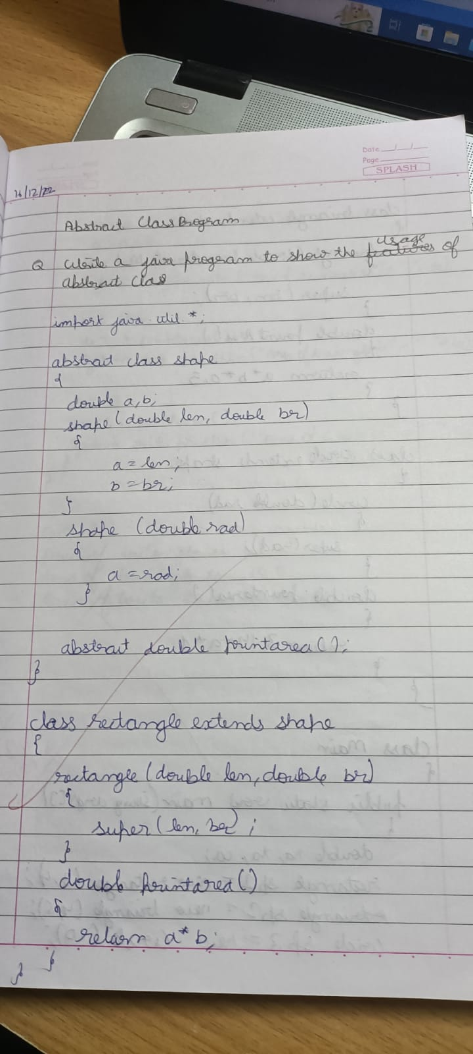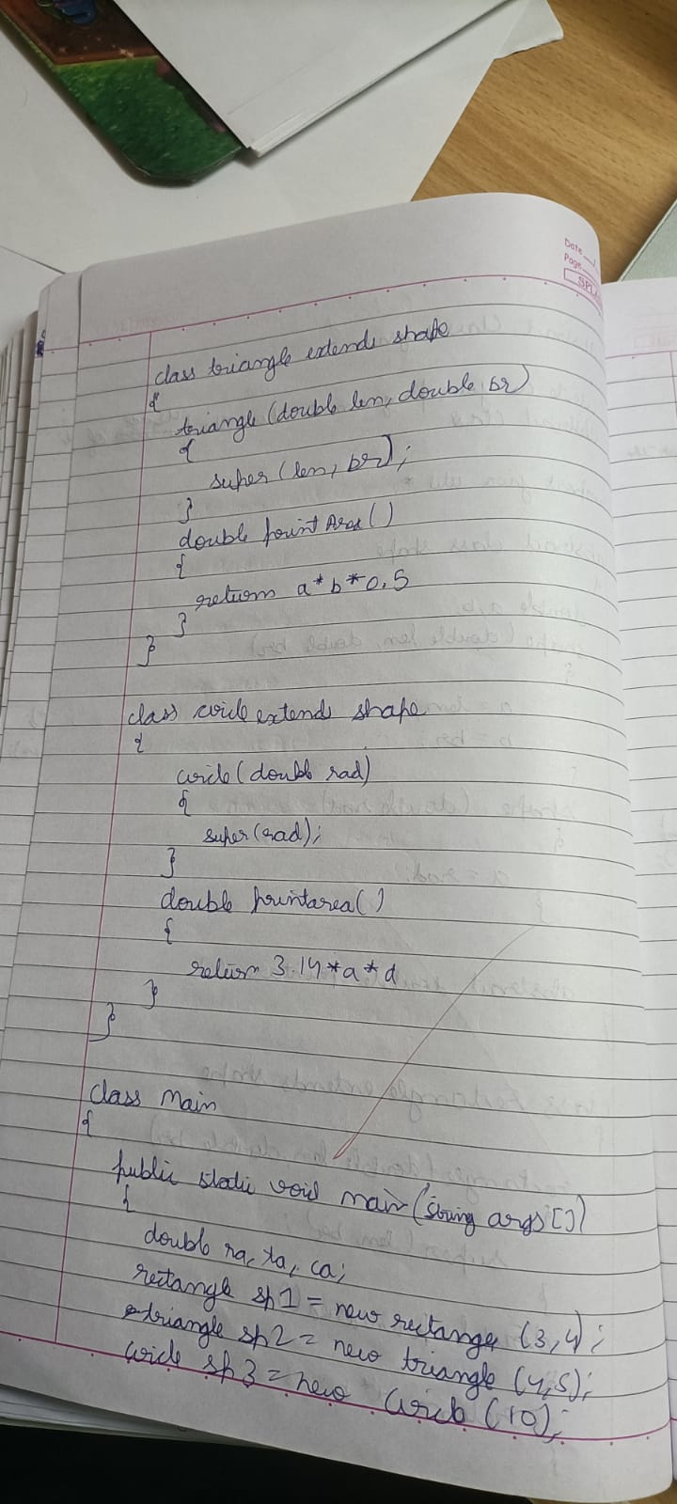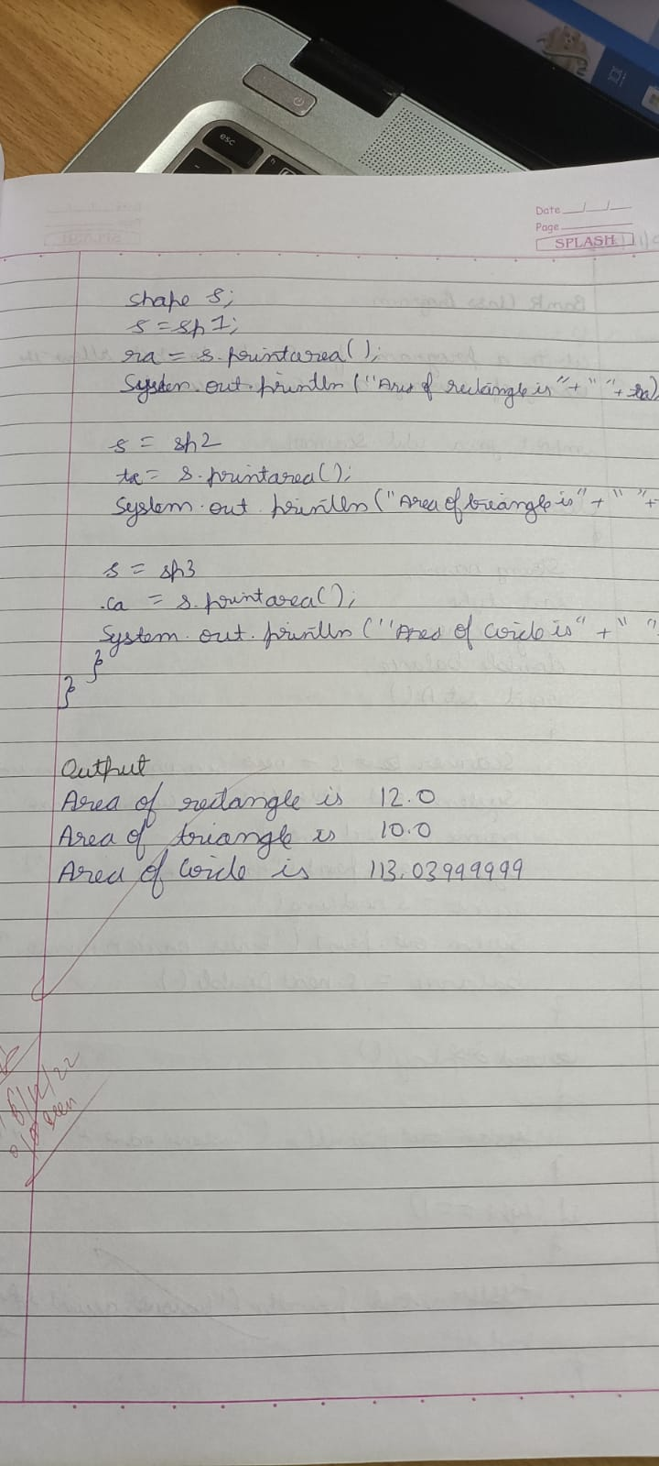

**OUTPUT:**

